My Target: ____ / 100 or ______ % Complete on the day of the test
(Circle when your test is handed back)

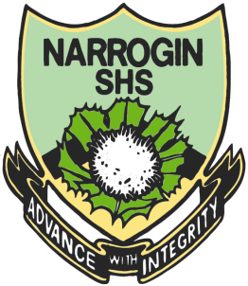
Name: __ Teacher:

Yr 7 Aboriginal Language & Culture Studies

Total marks  /100 | % | Weight  20%

Task Two

Bush Foods & Medicines

Due____________

Bush Foods – Animals

Choose one animal that has been a part of the Aboriginal people’s diet.

Draw a picture of it. 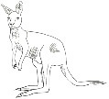 ( 5 marks)

Write down its characteristics. ( what it looks like) ( 5 marks)

___________________________________________________________

___________________________________________________________

___________________________________________________________

___________________________________________________________

___________________________________________________________

Write down its habitat. (where it lives) ( 5 marks)
___________________________________________________________

___________________________________________________________

___________________________________________________________

___________________________________________________________

___________________________________________________________

How is it hunted or collected? ( 4 marks)

___________________________________________________________

___________________________________________________________

___________________________________________________________

___________________________________________________________

___________________________________________________________

How is it cooked or eaten? ( 3 Marks)

___________________________________________________________

___________________________________________________________

___________________________________________________________

___________________________________________________________

___________________________________________________________

Choose one bird that has been a part of the Aboriginal people’s diet.

Draw a picture of it. 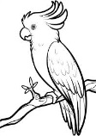 ( 5 marks)

Write down its characteristics. ( what it looks like) ( 5 marks)

___________________________________________________________

___________________________________________________________

___________________________________________________________

___________________________________________________________

___________________________________________________________

Write down its habitat. (where it lives) ( 5 marks)
___________________________________________________________

___________________________________________________________

___________________________________________________________

___________________________________________________________

___________________________________________________________

How is it hunted or collected? ( 4 marks)

___________________________________________________________

___________________________________________________________

___________________________________________________________

___________________________________________________________

___________________________________________________________

How is it cooked or eaten? ( 3 marks)

___________________________________________________________

___________________________________________________________

___________________________________________________________

___________________________________________________________

___________________________________________________________

Choose one insect that has been a part of the Aboriginal people’s diet.

Draw a picture of it. 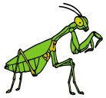 ( 5 marks )

Write down its characteristics. ( what it looks like) ( 5 marks)

___________________________________________________________

___________________________________________________________

___________________________________________________________

___________________________________________________________

___________________________________________________________

Write down its habitat. (where it lives) ( 5 marks)
___________________________________________________________

___________________________________________________________

___________________________________________________________

___________________________________________________________

___________________________________________________________

How is it hunted or collected? ( 4 marks)

___________________________________________________________

___________________________________________________________

___________________________________________________________

___________________________________________________________

___________________________________________________________

How is it cooked or eaten? ( 3 marks)

___________________________________________________________

___________________________________________________________

___________________________________________________________

___________________________________________________________

___________________________________________________________

Bush Foods – Plants

Now you need to look at plants that Aboriginals used as a source of food.

Name the plant. 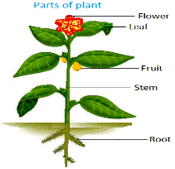 ( 2 mark)

___________________________________________________________

___________________________________________________________

___________________________________________________________

___________________________________________________________

___________________________________________________________

Draw a diagram of the plant. ( 5 marks)

What part of the plant is eaten? ( 5 marks)

___________________________________________________________

___________________________________________________________

___________________________________________________________

___________________________________________________________

___________________________________________________________

Where is the plant found? ( 3 marks)
___________________________________________________________

___________________________________________________________

___________________________________________________________

___________________________________________________________

___________________________________________________________

How is the plant food prepared? ( 4 marks)
___________________________________________________________

___________________________________________________________

___________________________________________________________

___________________________________________________________

___________________________________________________________

Does the plant have any other uses? ( 4 marks)
___________________________________________________________

___________________________________________________________

___________________________________________________________

___________________________________________________________

___________________________________________________________

Below are listed some Bush Foods, search them on the Internet and answer the questions about them.

Bush Potatoes.
What colour flower does this plant have? ( 1 mark)

__________________________________________________________

Quandong.
How high can this tree grow? (1 mark)

__________________________________________________________

Emu Plant.
Is this plant eaten raw or cooked? ( 1 mark)

_________________________________________________________

Onion Plant.
Does this plant have bulbs? (1 mark)

__________________________________________________________

Screwpine Pandanus.
How can you tell when this fruit is ripe? (1 mark)

___________________________________________________________

List 2 places where you can find Native Honey hives. (2 marks)

__________________________________________________________

__________________________________________________________

List 2 places where you can find Witchety Grubs. (2 marks)

__________________________________________________________

___________________________________________________________

In what kind of swamp can you catch Mud Crabs. (1 mark)

________________________________________________________

Where do Sea Turtles lay their eggs? (1 mark)

___________________________________________________________

END OF ASSESSMENT

